1.Who was the first chairman of TCS ?  
Ans: J R D Tata  
2.What is Universe of Blogs better known as ?  
Ans:Blogosphere  
3.Identify this logo

[](http://briteit.blogspot.in/)

 Ans:Moodle ( Modular Object-Oriented Dynamic Learning Environment )  
4.Expand Saas  
Ans:Software as a Service  
5.Who is regarded as the father of 'Pentium Chip' ?  
Ans:Vinod Dham  
6.Identify this person

[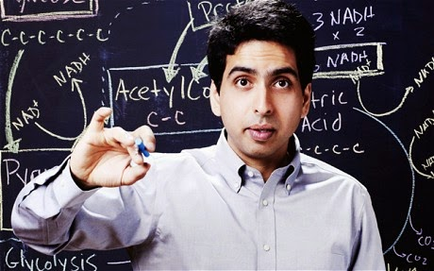](http://briteit.blogspot.in/)

Ans:Salman Khan(Khan Academy)  
7.Which company's headquarters is located at '1 Hacker Way' ?  
Ans:Facebook  
8.What was Microsoft's first ever product had helped them get a lot of money?  
Ans:MD DOS  
9.Which social networking site was founded by Dennis Crowley and Naveen Selvadurai ?  
Ans: Foursquare  
10..Which e-commerce website was launched through a provision in the 1999 Railway  Budget ?  
Ans:IRCTC  
11.US Dept of defense created a programming language after which pioneering lady in the same field in 1994. Who is she ?  
Ans:Ada Lovelace   
12.Which British pioneer in the world of computing was ranked way ahead of Tim-Berners Lee who was at 99.[Hint:has an award and test named after him]  
Ans:Alan Turing  
13.Named 'Dragon' this spacecraft became the first ever commercial spacecraft to venture into the International Space Station .Which company would you associate 'Dragon' with? [hint:its a word and a letter]  
Ans:SpaceX  
14. Eugene,Natalya,Sachin Tendulkar & Jackie Chan . What is the connection ?  
Ans:Kaspersky  
15.Which is the most downloaded app on Google Play [Hint:Made by Google]  
Ans:Gmail  
16.Identify the person

[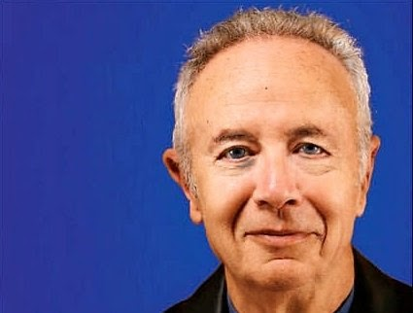](http://briteit.blogspot.in/)

Ans:Andy Grove  
17.Identify the game [hint:the 'Super' game]

[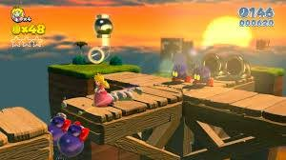](http://briteit.blogspot.in/)

Ans:SuperMario 3D  
18.Identify

[](http://briteit.blogspot.in/)

Ans:World Wide Web Consortium  
19.Who is being referred here?

[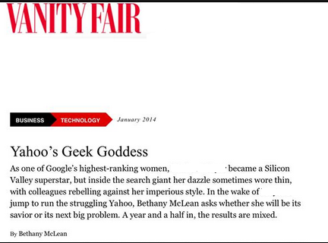](http://brietit.blogspot.in/)

Ans:Marissa Mayer  
20.Who owns this entity now ?

[](http://briteit.blogspot.in/)

Ans:Twitter